A NOTE FROM PASTOR
Welcome to Riverside Drive Baptist Church,
Today is a special day as we begin a week of celebration. Today, we praise Him as King of kings and Lord of lords just like those in Jerusalem did that first Palm Sunday. Praise Him with us today and worship Him as your Lord.
- Pastor Taylor
WEEKLY EVENTS
SUNDAY
- Sunday School
10:00
- Morning Worship 11:00
- Afternoon Worship 4:00
- All services are also available on Facebook Live

TUESDAY
- Digital Visitation
- 10:00 Zoom prayer meeting

WEDNESDAY
- Prayer Meeting
7:00
- In person or on Zoom

EVENTS & PROGRAMS
Digital Visitation – March 23 at 10:00 AM
Come by the church and pick up your mailing invitation list throughout the day. All we ask is that you provide the stamps. Invitations will be in groups of 10.
Soup and Salad Church Fellowship – March 28 at 4:00 PM
Enjoy a time of fellowship together following afternoon worship at 4:00.
Easter Sunday – April 4
Easter Sunday will be a special day. We will have many opportunities to serve as we look forward to having many guests with us. Please see Rachel for more information on how you can serve this Easter.
Ladies Movie Night – April 16 at 6:00 PM
For Ladies Bible Study this month, we will launch our new study with a fun movie night. Come enjoy snacks, a movie, and fellowship together. If you ordered a Bible Study book, you will also receive it that night. See you then.
VISITOR INFORMATION

We are honored that you chose to worship with us. All we ask is that you please fill out the connection card you received when you entered and return it in the offering. You can also fill out a connection card online by visiting our website. If you have any questions at all, please let us know. We pray that you are encouraged as you worship with us today.
CONTACT US
Office Hours: Tuesday-Saturday 9:00 AM - 5:00 PM
Email: riversidedrivebaptist@gmail.com
Website: Riversidedrivebaptist.org
Phone: (570) 782-5400
Visit us on Facebook and Instagram
OUR MISSION STATEMENT
Riverside Drive Baptist Church exists to…..
Engage with our Community
Edify the Christian
Exalt Christ
Birthdays in March
- Lana Michel (10)
- Sandy Bowen (6)
Bringing in the Sheets
3.28-Cathy 4.11-Rachel
4.4-Rowena 4.18-Mariam
Donations for Easter
As a part of our Easter EGGStravaganza, we will be sending out small Easter baskets to our online visitors through the month of March. We are looking for donations to help make and ship these baskets.
For more information, please see Rachel Taylor
WELCOME
Riverside Drive Baptist Church – March 28, 2021
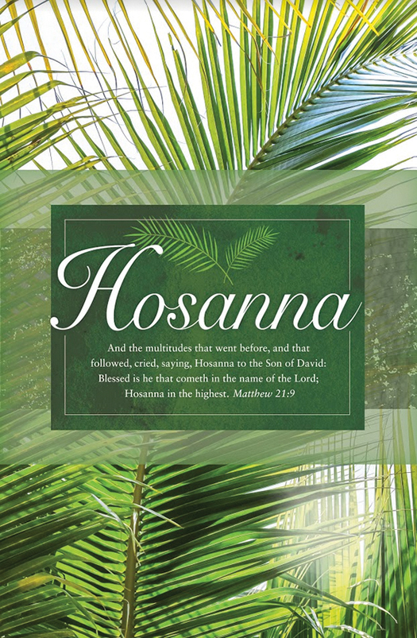
SERMON NOTES
___________________________________ ______________________________________________________________________ _________________________________________________________________________________________________________________________________________________________________________________________________________________________________________________________________________________________

